**Mini-NS FSW Test Macro Instructions**

A test macro has been provided to test the Mini-NS inputs and outputs. This macro issues commands to the Mini-NS and records the output packets. The result of this procedure is a binary file containing the output packets.

1. Terminology 2

2. Requirements 3

3. Run Instructions 4

3.1 Before Running the Macro 4

3.2 Macro Run Instructions 4

4. Appendix 13

# Terminology

Mini-NS – the Miniature Neutron Spectrometer

FSW – Flight Software

JTAG – JTAG Programming Cable

L2 – Level 2 FSW for the Mini-NS

TT – Tera Term terminal program

Workspace – the directory on the user’s computer where the L2 FSW is located

XC/XQ – The Zynq processors used on the Engineering/Flight boards, respectively

APID – A value used to identify the type of a Mini-NS CCSDS packet

USB-RS422 adapter – A cable used to connect the Mini-NS RS-422 to a serial port on the computer

# Requirements

To run the Test Macro, you will need the following software:

* Tera term terminal program – to talk with the Engineering board
* Spreadsheet editor (Microsoft Excel, etc)
* A text editor program
  + RMD uses the program “Notepad++”, [here](https://notepad-plus-plus.org/download/v7.6.3.html)
* An engineering board with XC processor programmed with L2 FSW

The hardware necessary for running this test is:

* Engineering board
* Xilinx JTAG Programming cable
* USB-to-RS-422 converter cable
* Power supply
* SD cards x 2
* SD card reader
* Computer to run the software above

# Run Instructions

## Before Running the Macro

The process described by these steps will guide the user through running the TT macro, “L2_XC_FSW_TEST_MACRO.ttl”, which will run the Engineering board through a set of tests which exercise the capabilities of the L2 FSW.

This process assumes the following items are complete:

* The user has a working Mini-NS Engineering board with the L2 BOOT files properly programmed into the EEPROM via the document “Loading Instruction Set onto Flight Board EEPROM”
* The user has TT or a suitable terminal interface program installed
  + A suitable alternative must accept “.ttl” files
  + A variable baud rate is also potentially useful
* The user has 2 SD cards to use with the Engineering board, one to be placed in each of the SD card slots, J3 (SD card 0) and J7 (SD card 1). The planned size for the SD cards is 32 GB.
  + The engineering board will only interface with specific types of SD cards; the ones provided by RMD are the ideal SD cards to use

## Macro Run Instructions

1. If you already have the L2 FSW downloaded from GitHub, skip to step 4, as you followed steps 2-3 while programming the board with the BOOT files.
   1. Before moving on, ensure that the directory where the FSW was downloaded is available.
2. Go to github ([link](https://github.com/RMDInc/LunaH_XC_FSW)) and download the project “LunaH_XC_FSW”.
   1. Click “Clone or Download”
   2. Click “Download Zip”

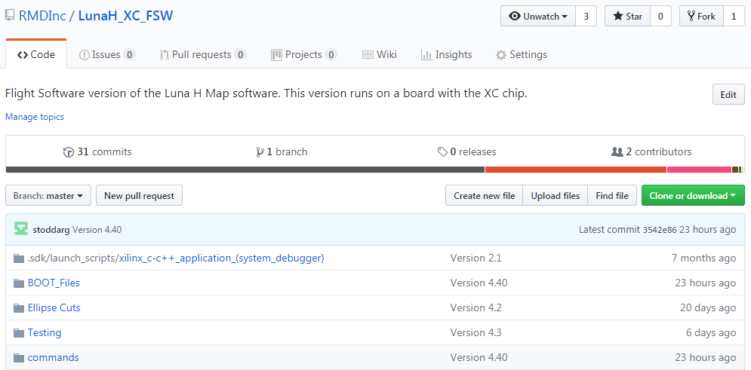

1. Unzip the data to a convenient and accessible location on your computer. The location is not important for the purposes of this document.
   1. The folder “Command Macros” contains an archive folder and another called TT Macros, which holds the command macros for each Level release of the FSW. We are interested in the L2 folder, which has the macros for Level 2.
   2. The “README.md” file contains version information for the rest of the code.
   3. The various other folders contain the source code for the instruction set.
2. Open the folder: Workspace > Command Macros > TT Macros > L2 to reach the macro for testing the L2 FSW
   1. There is another folder here with macros which can be adapted to test other/smaller sections of the L2 FSW, but that is not the focus of these instructions
   2. The file “L2_XC_FSW_TEST_MACRO.ttl” is what will be loaded into TT to test out the FSW
   3. There is an executable in this folder, “Packet Reader.exe”, which will be used to determine the results of the test.
3. Modify the Macro to the correct save file path
   1. Open the file macro file, “L2_XC_FSW_TEST_MACRO.ttl”, in a text editor
   2. Find the line which starts with "logopen" followed by a file path
      1. This should be line 12
      2. This is where the log file with the data packets will be generated
   3. Change the file path to the folder in step 4:
   4. ‘C:\my\path\Command Macros\TT Macros\L2\L2_MACRO_OUT.bin’
      1. The path must be put between single quotes: 'C:\my\path\L2_MACRO_OUT.bin'
      2. The path must use forward slashes \ \ \ between the folders
      3. The name for the file is given at the end of the path; the name that should be used is: “L2_MACRO_OUT.bin”, as seen above
   5. Now the line should be:

logopen 'C:\my\path\Command Macros\TT Macros\L2\L2_MACRO_OUT.bin' 1 0

* + 1. the command is "logopen" and there are three arguments:
       1. The file path
       2. 1
       3. 0
  1. Save the file and exit the text editor

1. Plug the USB-RS422 adapter into the computer’s serial port
2. Open TT
   1. Connect to the USB-RS422 adapter via the port it is plugged into
      1. If TT connects automatically, skip to step b, below, otherwise continue
      2. File > New Connection
      3. Press the radio button next to Serial and choose the appropriate port

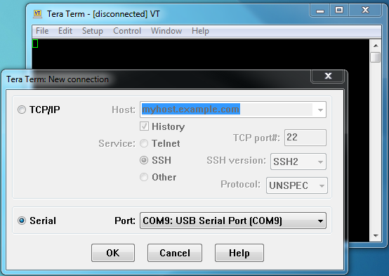

* 1. Open the setup options by clicking: Setup > Serial Port
  2. Verify the settings listed below
     1. Baud Rate = 921600
     2. Data = 8 bit
     3. Parity = None
     4. Stop = 1 bit
     5. Flow Control = None
     6. Transmit Delay = 0 msec, 0 msec
  3. Click OK

1. Prepare the SD cards
   1. Attach yourself to a grounding strap
   2. Ensure that power to the board is off
   3. Slide back the metal lid for the SD card holder
   4. Remove the SD card
      1. See below

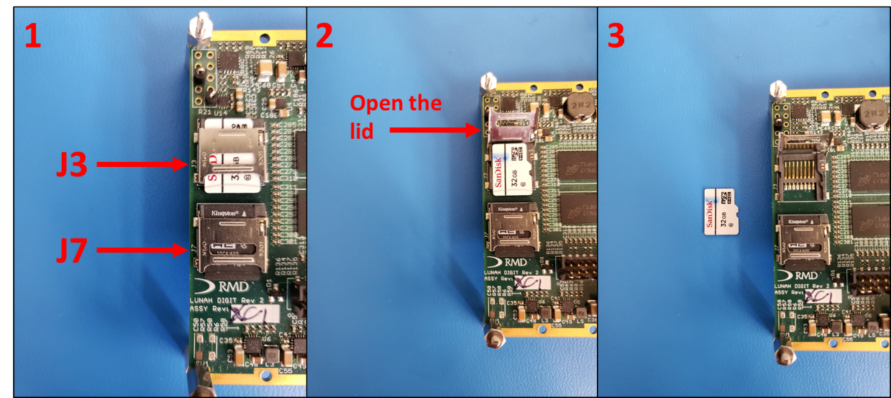

1. Delete files from the SD Card
   1. Plug the SD card into an SD card reader
   2. To ensure that the files created by the board are new for this run, delete the following files:
      1. MNSCMDLOG.txt
      2. MNSCONF.bin
   3. This will cause the system to create these new during the test and we can validate them
   4. Eject the SD card from the computer
   5. Remove the SD card from the reader
2. Replace the SD card
   1. Attach yourself to a grounding strap
   2. Ensure that power to the board is off
   3. Slide back the metal lid for the SD card holder
   4. Place the SD card gently back into the holder
   5. Push down on the metal lid and slide it closed on top of the SD card
3. Repeat Steps 8-10 with SD card 1 (J7) except
   1. When deleting files from SD card 1, the file to delete is:
      1. MNSCMDLOG.txt
4. Power on the board
   1. +12 V to the engineering board
   2. Ensure that both the green "Power Good" and "Done" LEDs are illuminated
   3. Once the system boots, it is now running and packets will begin to show up on TT, they can be ignored
5. From the TT file tab choose
   1. Control > Macro
   2. A file explorer window will pop up, navigate to the location where you unzipped the files from GitHub
   3. Go to the folder:
      1. Workspace > Command Macros > TT Macros > L2
   4. select the file L2_XC_FSW_TEST_MACRO.ttl

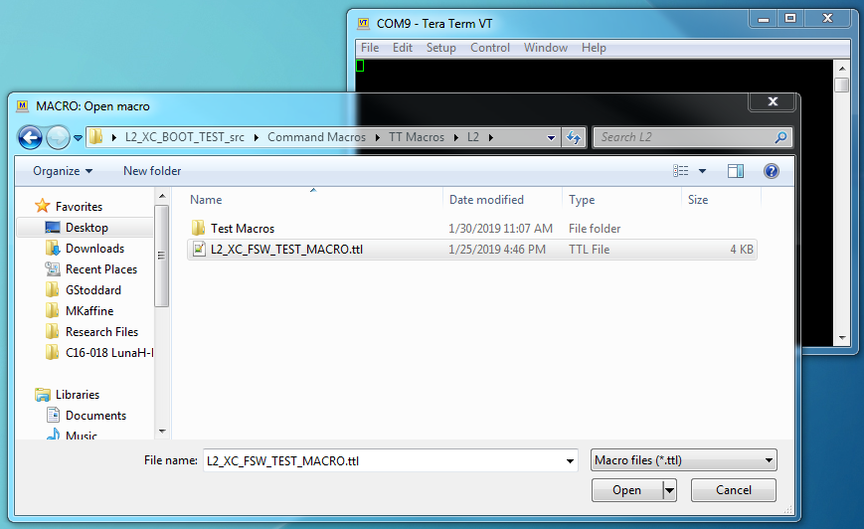

* 1. Click “Open” to have TT load the macro
  2. The macro will load automatically and TT will start it
  3. When the macro starts, TT will minimize itself and pop up a small box:

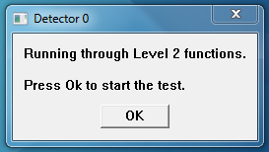

* 1. The TT macro is now ready to run.

1. Press OK to start the test
2. This will start issuing commands to the engineering board and collecting the output.
3. A secondary box will pop up, see below:

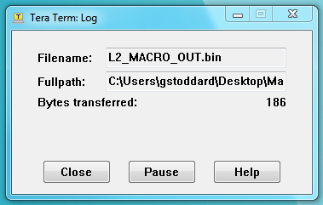

1. This box shows the TT Log and tells you how many bytes have been recorded so far. The bytes transferred number should be incrementing
2. Also shown is the Filename and path to where the log file is being saved.
3. The test takes around just over a minute to run (~72 s) and will close itself.
4. The log window will close automatically.
5. The TT window will stay minimized.
6. Restore the TT window and verify that packets are still appearing there
   1. The packets which appear will look like the following:

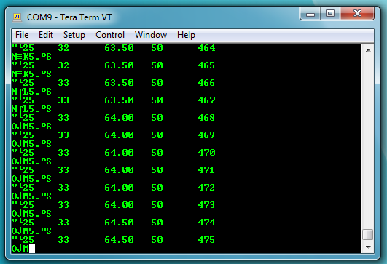

1. When the macro has finished running, power off the board
2. Retrieve the SD Card 0 (J3) from the engineering board
3. Attach yourself to a grounding strap
4. Ensure that power to the board is off
5. Slide back the metal lid for the SD card holder
6. Remove the SD card



1. Retrieve files from the SD Card
2. Plug the SD card into an SD card reader
3. There should be 2 files on SD card 0:
   * 1. MNSCMDLOG.txt
     2. MNSCONF.bin
4. Copy MNSCONF.bin into the folder with the test macro:
   * 1. Workspace > Command Macros > TT Macros > L2
5. The contents of the L2 folder should now be:
   * 1. The Test Macros folder
     2. L2_MACRO_OUT.bin
     3. L2_XC_FSW_TEST_MACRO.ttl
     4. MNSCONF.bin
     5. Packet Reader.exe
6. Double click the Packet Reader executable to launch it.
7. It will automatically start and analyze the binary files from the test run.
8. The executable will write information to the TT screen to inform you of how the test went. The screen should look like this:

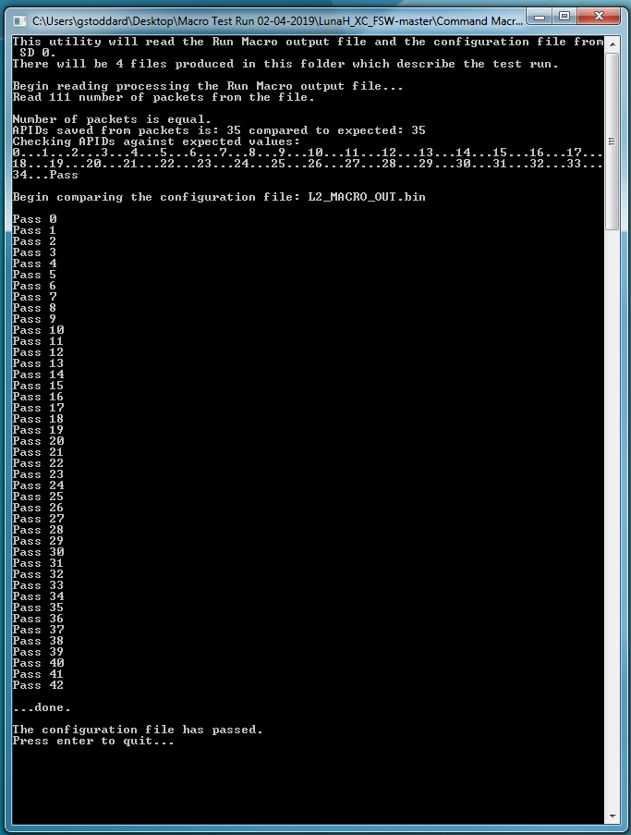

1. The number of packets read from the file may be different each run
2. There will be four files produced by the packet reader executable:
   * 1. L2_config_analyze.txt
     2. L2_packets_noSOH_vals.txt
     3. L2_packets_raw_vals.txt
     4. L2_packets_read.txt
3. There are two situations where the output of the executable will not look like the picture above, they are:
4. If either the MNSCONF.bin and/or the L2_MACRO_OUT.bin files are missing from the folder when running the executable, then it will issue that error message and quit
5. If the configuration file does not pass the comparison check, then there will be failure statements instead of a Pass statement. At the end of the window, the program will tell you to check the “L2_config_analysis.txt” file to see which configuration parameters did not pass. In that case, a deeper analysis will need to be done to determine why the comparison did not pass, email Graham if this happens.
6. The packet reader will analyze both the configuration file and the output packets from the run and issue a Pass/Fail judgement for both. The output packets are analyzed first and are compared to an expected set of outputs. If they are the same, then a pass is reported. The same procedure is taken for the configuration.
7. If both files have passes, then the test is successful; if that is not the case, email Graham.

# Appendix

Include sample files and perhaps breakdowns